Sign
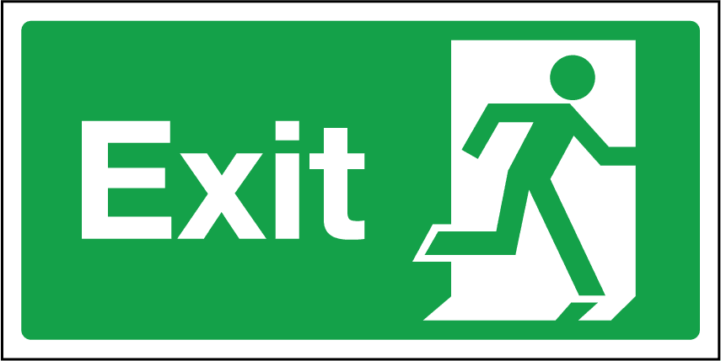

Symbols for holiday

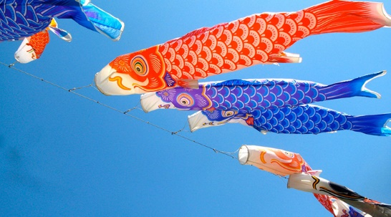
Kodomonohi

1). From the picture, which sentence is correct?
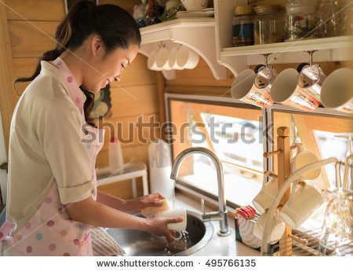
1. She is doing homework. 2. She loves playing outdoor sports.
3. She helps her mother does housework. 4. She cooks special dinner for their family.
2). What do you think about the this woman? She is ___
1. intelligent 2. impolite 3. difficult 4. diligent
3). At the book shop
Jonathan: …………………………….
Shopkeeper: Twenty five baht.
1. How many books are there? 2. How much is it?
3. How often do you read? 4. How long is it?
4). Ann: The weather is very hot. Let's go to the beach!
Beth:……………………… I love to swim in the sea.
1. That's a good idea. 2. That sounds dangerous.
3. That's very kind of you. 4. That seems very unhappy.
5). John: What do you like to do in your free time?
Jane: I like reading and watching TV. ……………..
John: I collect stamps.
1. How are you? 2. How about you?
3. What do you do? 4. What are you doing?

