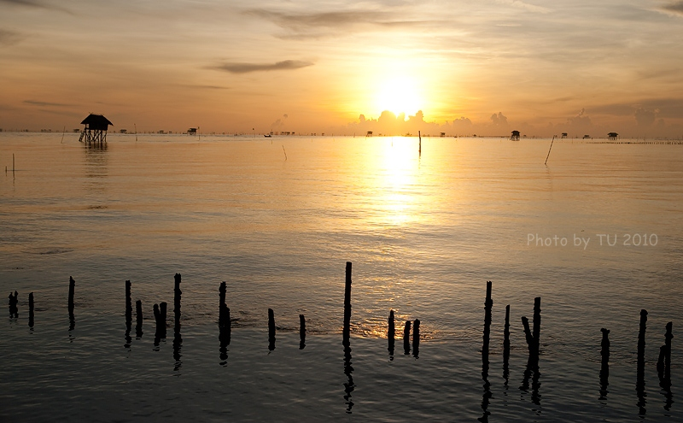

พระอาทิตย์ขึ้นที่บางตะบูน

[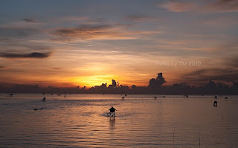](http://2.bp.blogspot.com/_pIOa7HtcmIY/TKDxyTTXX_I/AAAAAAAAAuc/gIPgHGrx2tc/s1600/%E0%B8%9A%E0%B8%B2%E0%B8%87%E0%B8%95%E0%B8%B0%E0%B8%9A%E0%B8%B9%E0%B8%995.jpg)

[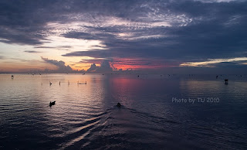](http://2.bp.blogspot.com/_pIOa7HtcmIY/TKDxxq-dJoI/AAAAAAAAAuQ/TubIRV0OvMM/s1600/%E0%B8%9A%E0%B8%B2%E0%B8%87%E0%B8%95%E0%B8%B0%E0%B8%9A%E0%B8%B9%E0%B8%991.jpg)