Title: Cultural Conservation in Myanmar and Interest in Sufficiency Economy
Column: Searching for Old Cities
Author: Paradorn Sakda
Source: Siamrath Weekly. 9th -15th November 2012, page 50-51.

Dawai Deep-sea Port is still hot news because it is a mega project and challenge. Therefore, we have to keep our eyes on Myanmar.
To be in trend, I have to stop searching for old cities. Then, I closely follow my eyes on Myanmar’s development after its opening to the modern world.
Ms. Parichart Borisute who used to go to Myanmar with me several years ago called me that Prof. Dr. Chira Hongladarom invited her to join his big group of 17 people to Myanmar. Prof. Dr. Chira Hongladarom’s work is very important and beneficial especially for strengthening People-to-People Diplomacy (PPD). Thus, I would like to share this story the readers.

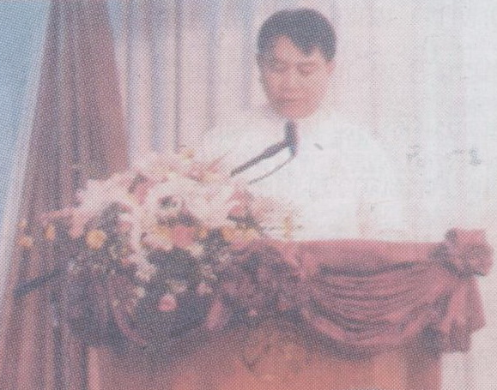 | 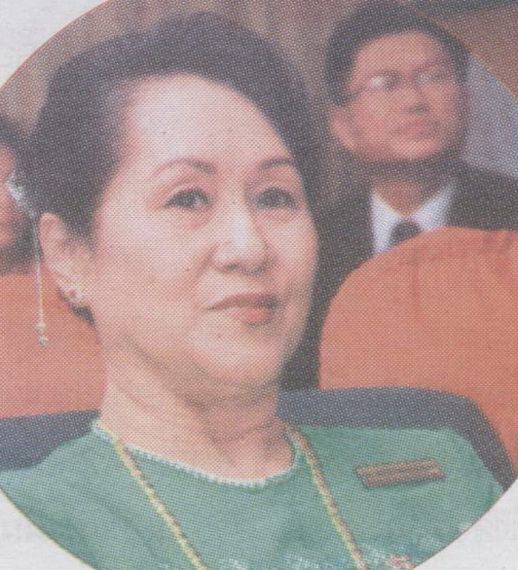
H.E. U Aye Myint Kyu, Union Minister, Ministry of Culture, Government of the Republic of the Union of Myanmar delivered the opening speech. | Prof. Dr. Daw Khin Sway Myint was the leader of Burmese co-hosts.

Prof. Dr. Chira Hongladarom and group departed from Thailand on 1st October 2012 and stayed for three days at Asia Plaza Hotel Yangon.
Besides promoting People-to-People Diplomacy (PPD), Prof. Dr. Chira Hongladarom focused on making presentations on several topics especially cultural conservation and tourism in Myanmar including many tourist attractions.
The Burmese side warmly welcomed the Thai Delegation. Several VIPs joined this seminar especially H.E. U Aye Myint Kyu, Union Minister, Ministry of Culture, Government of the Republic of the Union of Myanmar.
I would like to tell some stories in flashback.
Last year, Prof. Dr. Chira Hongladarom went to Myanamr to discuss about tourism with H.E. U Aye Myint Kyu, Union Minister, Ministry of Culture, Government of the Republic of the Union of Myanmar who was Deputy Minister of Sport at that time.
After that, the Burmese side requested for the Study Visit on tourism in Thailand. They were very interested in Sufficiency Economy and requested for Master’s Degree scholarships for 15 university professors.
Foundation for International Human Resource Development (FIHRD) cooperated and supported these Burmese university professors.
This is a short story of Prof. Dr. Chira Hongladarom and group’s trip to Myanmar.
From this trip, Prof. Dr. Chira Hongladarom and group saw enthusiasm of public, private and academic sectors of Myanmar. All of them joined the seminar. This phenomenon reflects strong collaboration because Myanmar has to step into AEC and reach the same level of development as other ASEAN countries.
The seminar’s workshop generated satisfying outcome. According to the workshop, Myanmar has a lot of archaeological sites and other types of tourist attractions. Myanmar has the advantage of geography.
As the Secretary – General of Foundation for International Human Resource Development (FIHRD), Prof. Dr. Chira Hongladarom could absorb a lot of knowledge and understanding as take-home value.
H.E. U Aye Myint Kyu whom Prof. Dr. Chira Hongladarom met on this trip and acquainted with has been promoted to exercise full power as the Minister of Culture so he can fully support this seminar.
Burmese people including public, private and academic sectors are enthusiastic about stepping into AEC.
Myanmar was like a Sleeping Beauty. When it gets up, it is open to the new trends.
Environment and natural resource conservation in Myanmar is quite good because the Burmese are nature lovers. Even though they do not pay attention to antiques but never destroy them. Therefore, when Myanmar becomes open and knows that nature-loving activity is the world’s trend, they protect their nature.
I saw a lot of piles of wood becoming stone in front of a Burmese millionaire’s house near the Irrawaddy River. I was surprised to see many of these.
At 200-year-old U Beng Bridge across Tongtaman Lake, some parts of the bridge became stone. It was incredible.
Many related organizations and interested people joined this seminar.
Prof. Dr. Chira Hongladarom and group’s lecture tour went beyond expectation.
Besides strengthening People-to-People Diplomacy (PPD), there will be closed cooperation in the future.
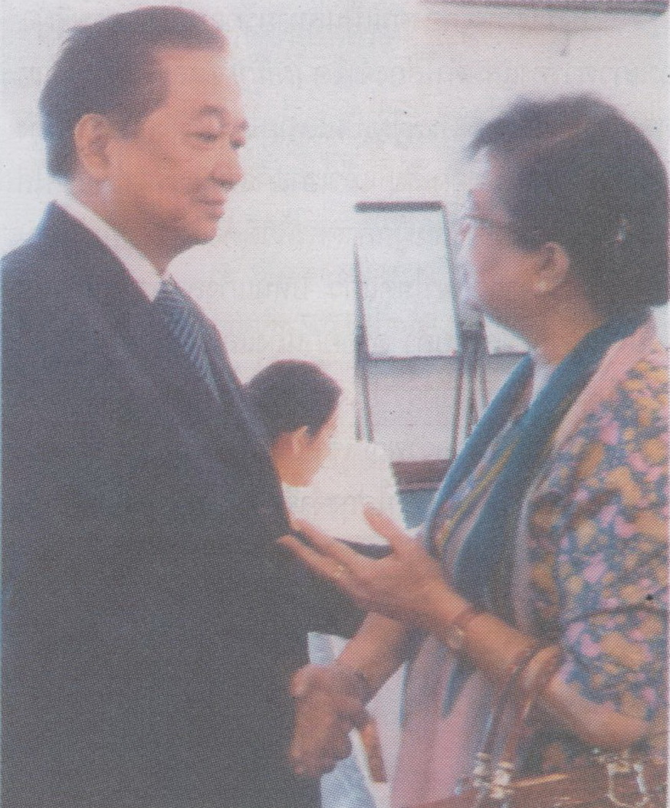 | 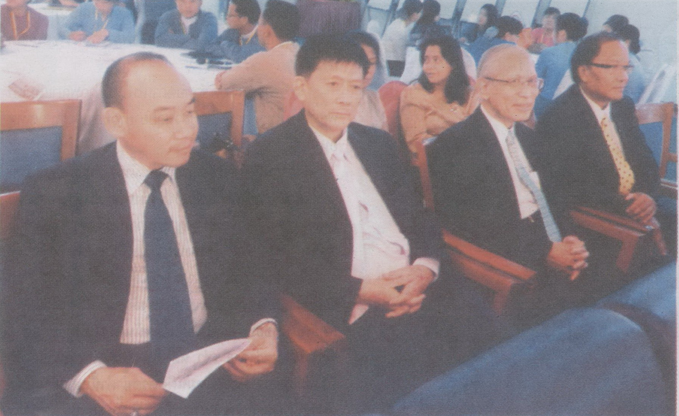
Prof.Dr. Chira Hongladarom shook hand with Daw Kyi Kyi Aye, Senior Tourism Expert of Myanmar Ministry of Hotels and Tourism. | From left, Mr.Rawipas Klamthawee, Mr. Satit Anantasomboon, Prof. Krairit Boonyakiat  and Mr. Tumnong Dasri joined the seminar.

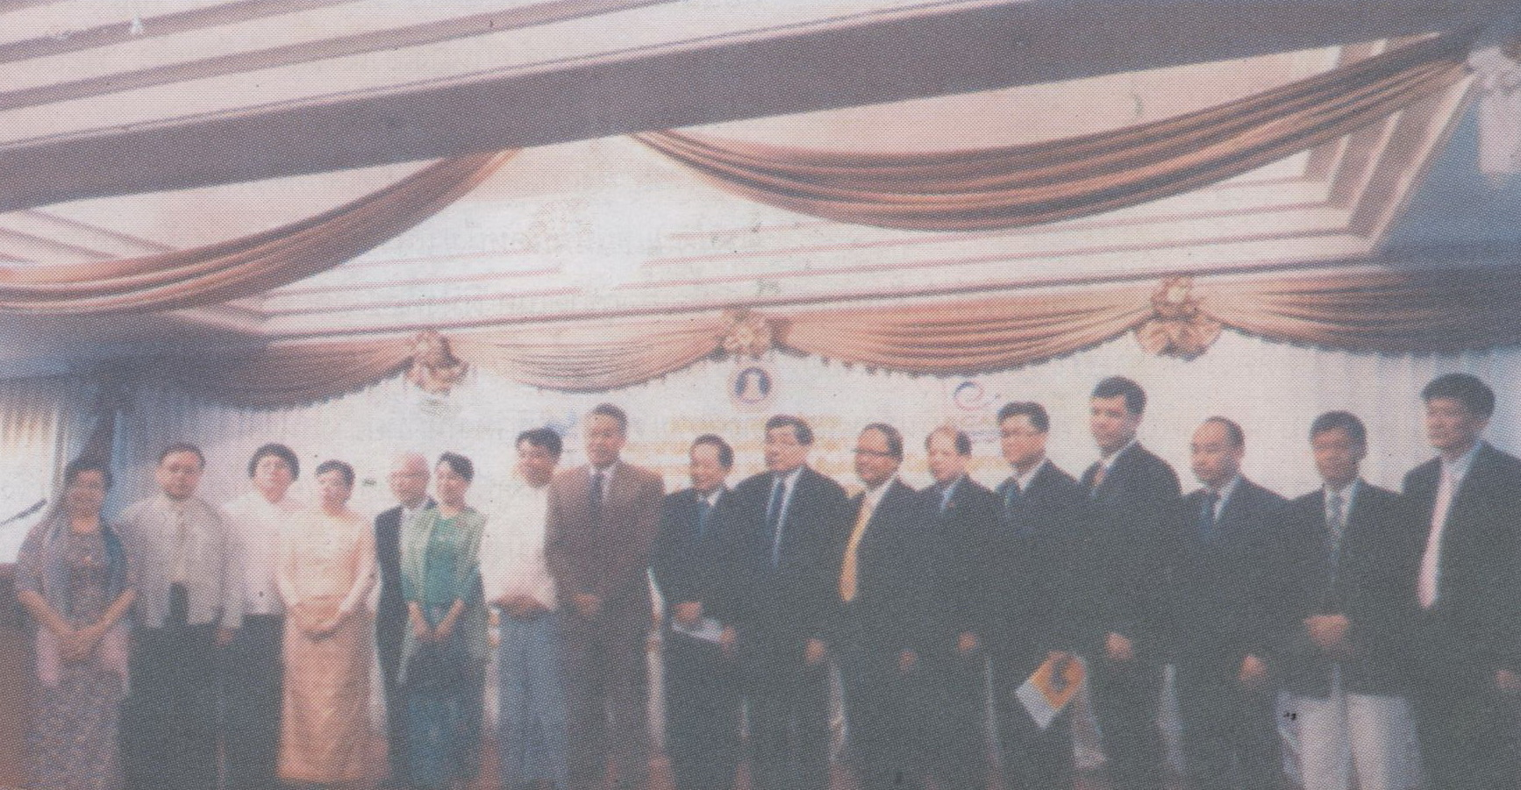

Group Photo after the Closing Ceremony.

