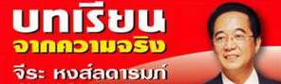

Newsletter
dr.chira@hotmail.com
Saturday 21 May 2011 www.chiraacademy.com

Title: People to People Diplomacy in Chiang Mai: Cambodia-Thailand Relation
Column: Learning from Reality with Dr. Chira Hongladarom
Source: Naewna. May 21, 2011, p.5

People to People Diplomacy in Chiang Mai: Cambodia-Thailand Relation

This week, there were several events.
Dominique Strauss-Kahn, former Managing Director of the International Monetary Fund (IMF) was charged for raping maid in a luxury hotel in New York. This news became scandal. All readers may remember my article on “Shakespearean Tragedy”. The lesson learnt is that people who are good at work may be badly-behaved like Kahn. He could not control himself because he lacked Emotional Intelligence. This was his weakness and destroyed him. Expectation on Kahn as a candidate for France’s future president has doomed. Thai politicians must be careful about this.
This week, there was an important political fight between Abhisit and Yingluck. Thaksin devoted everything to help his sister succeed in politics. We have to wait and see if he has made a right decision. I know Thai politics is dangerous.
Why did he do that? Thaksin did not trust anyone except his relatives. Samak who used to be Thaksin’s nominee later could not be controlled. Therefore, he chose his sister to serve for him.
If Peu Thai Party won this election and formed the new government, they might be hurried to pass amnesty law. I was surprised why Peu Thai Party did not promote amnesty for Thaksin as policy. Were they afraid of losing votes?
Abhisit must lead his team to fight with Thaksin’s party. This is a test for Abhsit’s leadership potential for developing new leaders with ethics and knowledge.
We have to closely look at Thai politics. An important question is that after following up Thai politics, what will Thais benefit? It seems politicians benefit. People are not included.
I hope Thai politics development will hopefully move forward with sustainability. I believe there are 3 reasons for this.
- Thai society has become more open. There is more information sharing and social media usage.
- Most Thais are non-violent and well-wishers.
- Thai education opportunity has expanded more.
A weakness is that we have a lot of educational degrees but Thai people must think before they decide. Thais lack thinking and reasoning skills.
Therefore, people’s politics must investigate and strengthen the government. Press like Naewna newspaper or FM 96.5 MHz radio program can help a lot.
On May 17-19, 2011, I went to Chiang Mai, I always work on People to People Diplomacy (PPD).
- What did I do in Chiang Mai?
The answer is PPD activities.
- What is PPD?
PPD can exist with or without the support from the government. The government can support without control or promoting the government’s only objectives. However, the country must be benefit. For example, if I went to Laos, the Thai Ambassador also joined the project organized by academic and people.
A weakness is that the government has a lot of resources but lacks ability to lead PPD. Sometimes, the government creates misunderstanding.
What is the problem? The government runs the projects focusing too much on the government’s benefits without win-win results. The government should share benefits with other countries and create sustainability for government and Thais.
PPD is a concept initiated by H.E. Prof. Kasem Watanachai, MD., Privy Councilor, who travelled with me to Cambodia on behalf of Foundation for International Human Resource Development (FIHRD). He impressed Cambodian officials and farmer leaders by promoting Sufficiency Economy. PPD not only includes
- money
- projects
- activities
Trust must be created based on the King’s concept on understanding, reaching out and development.
Understanding and reaching people is to understand their culture history and cultural diversity. We must be careful with words and actions. In Laos, Thais should not present us as a big brother to Laotians. At first, we must show that Thais are Laotians’ relatives and treat them with equality and respect.
2-3-day event in Chiang Mai was successful because of the following reasons.
- M.L. Panadda Disakul, Chiang Mai Governor presided over the opening ceremony of Social Network activities “Get Together Party”. He was an official who understands this concept and emphasized its importance to the delegates of this workshop.
- I created environment for delegates from 6 GMS countries: Laos, Cambodia, Vietnam, Myanmar, China and Thailand at Intensive Workshop on Energy and Environment Sector Cooperation among GMS Countries (Phase 2) on May 17-June 5, 2011.
- We got Cultural capital from Chiang Mai which linking good relationship such as wrist ties ceremony for delegates but Laos’ delegate also made it for me.
- Even though Thailand International Development Cooperation Agency (TICA) was the main sponsor, we did not think Thailand was the most important. All countries were equal. We freely and closely exchanged ideas.
- The highlight of Chiang Mai is that among conflict between Thailand and Cambodia, Cambodian government sent 4 delegates as follows.
- Mr. Meng Sokkheng"Deputy Director of Training Center of Electricity"
- Mr. Chhunn Chhim "Head of Renewable Energy Office of Department of Energy Technique"
- Mr. Sy Moeng "Head of Technical Training Office"
- Mr. Khlaut Ousa "Official of Department of Energy Technique"
They came to join 20-day project. This could relieve tension well and be a small point for creating good and sustainable relation between Thailand and Cambodia.
This is benefit of PPD.

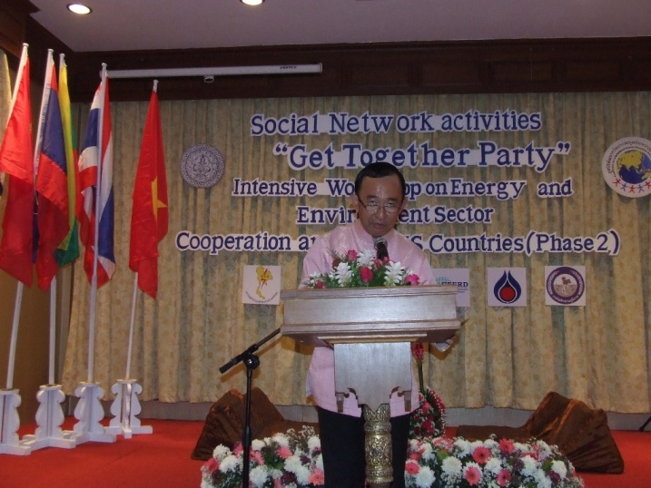 | 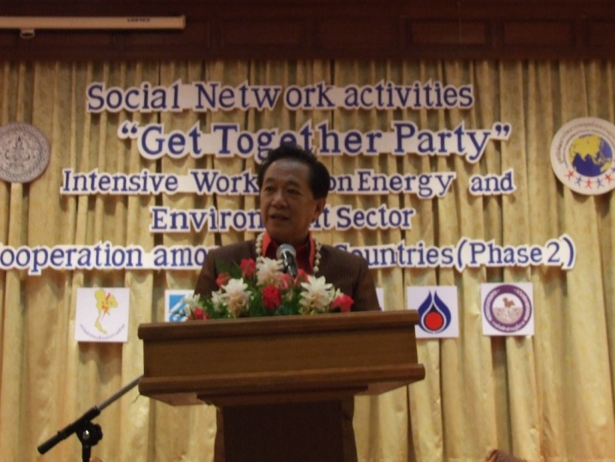
M. M.L. Panadda Disakul, Chiang Mai Governor presided over the opening ceremony of
So Social Network activities “Get Together Party” of Intensive Workshop on Energy and
Environment Sector Cooperation among GMS Countries (Phase 2) on May 17, 2011
at Khum Khantoke, Changmai.

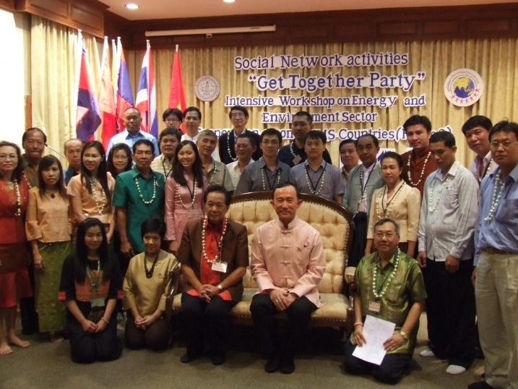 | 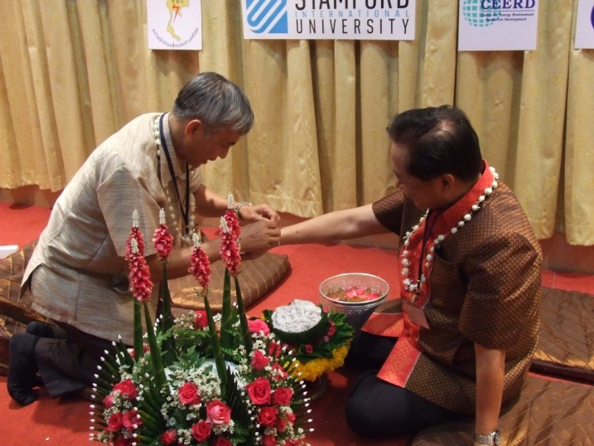
GMS delegates and all guests joined group photo after the opening ceremony of Social Network activities “Get Together Party”. | Laos’ delegate tied Prof. Dr. Chira Hongladarom’s wrist.

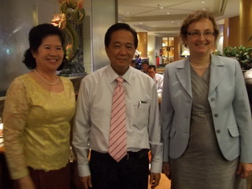
H.E. Mrs. You Ay Ambassador of Cambodia (left), and H.E. Ms. Sirpa Maenpaa, Ambassador of Finland (right) joined group photo with Prof. Dr. Chira Hongladarom at Intensive Workshop on Energy and Environment Sector Cooperation among GMS Countries (Phase 2) on May 21, 2011 at the Miracle Grand Convention Hotel, Bangkok.

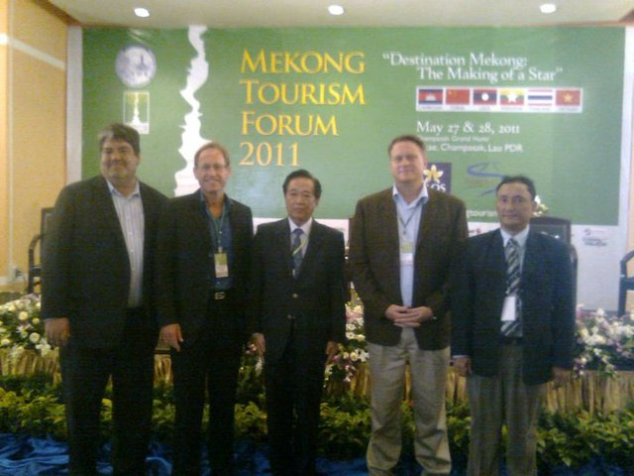

Mekong Tourism Forum 2011 on May 27-28, 2011 in Pakse, Champasak, Laos

Prof. Dr. Chira Hongladarom

www.chiraacademy.com www.fihrd.org
dr.chira@hotmail.com Tel. 662-619-0512-3
Tel. 662-619-0512-3 Fax. 662-273-0181
Fax. 662-273-0181

